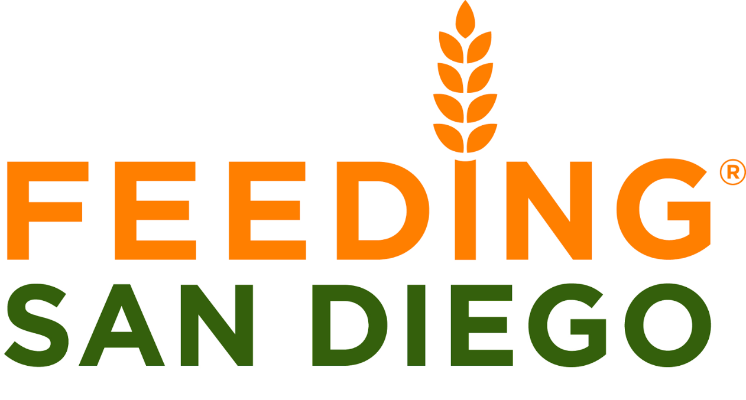

Feeding San Diego is a non-profit organization devoted to bring hunger relief throughout U.S.A by distributing healthy and nutritious food to San Diego residents who are food insecure. They work with local partners and network of volunteers to serve 63,000 children, families and seniors in need.

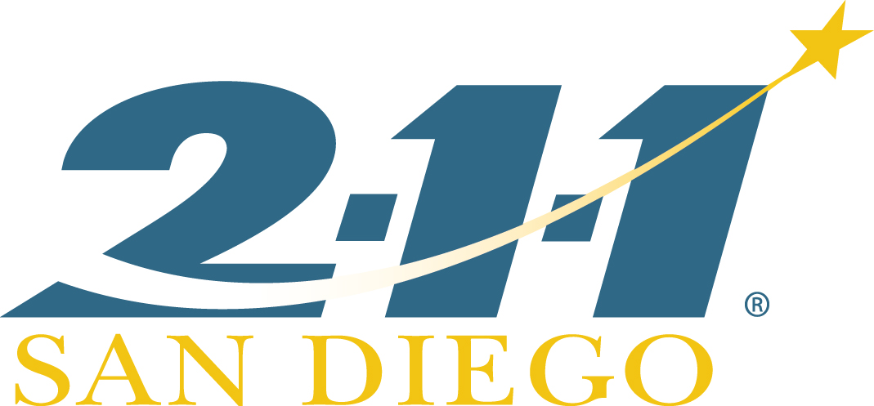

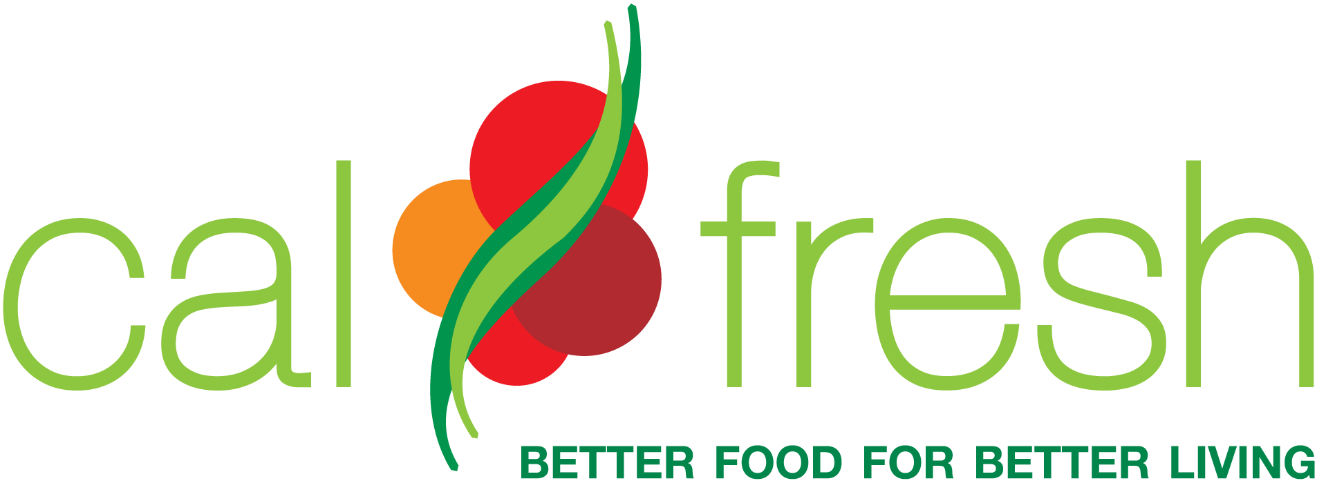

CalFresh is a program that assists low-income households purchase healthy and nutritious food. CalFresh, also known as SNAP, provides a monthly food budget to help households maintain adequate food nutrition levels. This benefit amount depends on family size, income, and other monthly expenses.

If you have an immediate food need, CalFresh Expedited may allow you to receive CalFresh within three days.



Our services are inspired by 2-1-1 San Diego, a 9am-5pm service with highly trained Client Service Representatives speaking over 200 languages and dialects. 211 offers similar services and navigates clients through their situations by assessing their needs and matching them to the best and closest resource in their community.